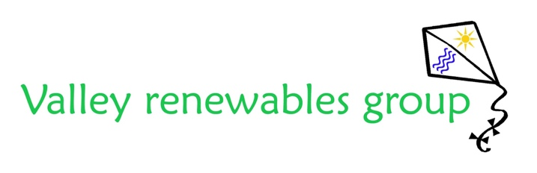
The Development Trust for the Carron Valley
Please return completed applications forms to admin@valleyrenewables.co.uk
We aim to respond with notice of award within 4 -6 weeks of receiving completed applications.

This is an application form for a VRG Energy Efficiency Grant

Please read the guidelines and eligibility criteria carefully before completing this form and ensure your application meets the stated eligibility criteria. If you require any assistance with the completion of this form, please contact admin@valleyrenewables.co.uk

Name of Applicant and Contact Details: Please print.

Name:_________________________________________________________________

Address: ______________________________________________________________

__________________________________________________Postcode: ____________

E-Mail:-___________________________

I confirm this is my primary residence. (If not please give details overleaf.)

DECLARATION - By submitting this form you are agreeing to the following:-
I certify the information contained in this application is correct.
I confirm that if I receive a grant from VRG I will only use the funds for the purpose detailed in the
application.
I agree to my personal details being used by VRG in accordance with their published Privacy Statement.

I certify this is a bona fide grant application and agree that the Directors award decision is final.

Authorised Signature/Position: _____________________________/__________

Please Print Name:__________________________________________________

Date:________________________

For Valley Renewables Use only:

Application Number: Acknowledged: Household no:

Date Discussed: Result:

Amount: Notification:

Quote supplied:

Receipts received: Cheque Sent: Cheque no:

ABOUT THE APPLICATION

- Please tell us what you are applying for funding for. What is the purpose of your application and what do you want to do?

- The Energy Efficiency Scheme’s primary purpose is to tackle climate change and to support energy efficiency. Please state how this grant would help you to do this and, where possible, provide evidence to support this.

- When do you want to start and how long will it take? (Please note we cannot accept retrospective applications.)

PROJECT IMPACT

- How many individuals are expected to directly benefit from this grant?

- How many households are expected to directly benefit from this grant?

- What will be the outcome of the grant when completed (i.e. what do you hope to achieve)?

COSTS Please provide supporting quotations where applicable.

You can apply for up to £2000 except for log stores which are up to £200

- What is the total cost of your proposal? £
(please provide a breakdown if there are a number of items included in this cost)

- How much money are you applying for? £

- Would VRG Funding cover the full cost of the proposal:
    - ☐ Full cost (Move to Question 11) ☐ Partial (Move to Question 10)

- Please state where additional funding for this proposal will this come from (e.g. Personal finance, other grant, please include further details about other grants applied for and the total amount secured).
- Payment required upfront. ☐ Yes ☐ No

Please note that a quote from a recognised supplier is required if payment following grant approval is required. Please email to admin@valleyrenewables.co.uk

- Do you have an up to date Energy Performance Certificate for the property for which you are applying for a grant?

☐ Yes ☐ No
If YES what is your current rating?
This question is not compulsory. Failing to complete this will not bar you from receiving a grant but answering it will assist us in providing you with a speedier response and help our commitment to best governance and accountability for spending community funds.

All grant awards are subject to funds remaining available and applications meeting the required criteria.

- Any other relevant information?

If your application is successful VRG may be in touch to produce a short case study. Case studies are an important way for us to inspire other residents and monitor the impact of our grants. If you do not wish your grant to be used as a case study please tick here: ☐

All successful applications will be emailed a monitoring and evaluation form within 6 months of their grant receipt. The form is designed to ensure VRG’s Grant schemes continue to provide value and impact for the community. Your assistance in filling out the evaluation form when received would be greatly appreciated, however completion of evaluation is not a condition of award.

Please return completed applications forms to admin@valleyrenewables.co.uk

Or post to Admin Assistant, Valley Renewables Group, 61 Larbert Road, Bonnybridge FK4 1EN

Thank you for your interest in a VRG Grant.
To keep up to date with VRG Grants and activities please follow us on: facebook.com/valleyrenewablesgroup

